**P235/1**

**Islamic Religious Education**

**(The Glorious Quran)**

**Paper 1**

**July/August 2019**

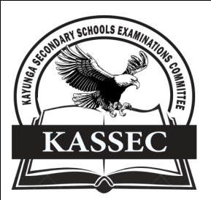

**KAYUNGA SECONDARY SCHOOLS EXAMINATION COMMITTEE**

***Uganda Advanced Certificate of Education***

**JOINT MOCT EXAMS 2019**

**ISLAMIC RELIGIOUS EDUCATION**

**(The Glorious Quran)**

**PAPER ONE**

**INSTRUCTIONS TO CANDIDATES**

* Answer **four** questions only
* All questions carry equal marks.

1. Examine the modes of revelation according to the Quran. *(25 marks)*

2. Account for the authenticity of the Holy Quran *(25 marks)*

3. Discuss the Quranic teachings on the soul. *(25 marks)*

4. (a) Discuss the conditions the dead experience in the grave. *(13 marks)*

(b) How does the above experience benefit the living Muslims? *(12 marks)*

5. Analyse the Quranic teachings on the status of a woman in Islam *(25 marks)*

6. (a) Discuss the Quranic teachings on brotherhood *(13 marks)*

(b) What is the significance of Islamic brotherhood to society? *(12 marks)*

7. Examine the guidance offered by the Quran in business transactions*.(25 marks)*

8. (a) Analyse the Quranic teachings on Zakah *(13 marks)*

(b) Explain the significance of Zakah to Muslims *(12 marks)*

9. Discuss the features of political system according to the teachings of the Quran *(25 marks)*

10. (a) Explain the conditions under which a Muslim is permitted to engage in

Jihad. *(13 marks)* (b) Analyse the significance of Jihad to Muslims *(12 marks)*

11. (a) Examine the themes of surat inshirah *(13 marks)*

(b) What lessons can be learnt from the surah? *(12 marks)*

12. (a) Discuss the content of surat al Asr (103) *(15 marks)*

(b) Analyse the lessons learnt from this surah by Muslims. *(10 marks)*

**END**